AP CSP CodeBot
MISSION 6 Obj 1-3 Line Follower |  | Time: 45 minutes
Project Goal: Students will learn about Boolean lists.  Learning Targets  - I can use REPL to gather real-time data from sensors. | Key Concepts  - There is no “hidden magic” going on here! The ‘bot responds to programmed inputs and outputs.
Assessment Opportunities  - Mission 6 Obj 1-3 Assignment  - Quiz after Objective 2  - Submit the “CheckLines” program | Success Criteria  - Read data from a line sensor and display it on the Console Panel.
AP CSP Framework  DAT-2.D Extract information from data using a program.  AAP-2.E Write expressions using relational operators and evaluate those expressions.  AAP-2.K Write iteration statements.  Computational Practice 4.C Identify and correct errors in algorithms and programs, including error discovery through testing. | Materials  - Mission 6 Obj 1-3 Assignment / Answers  - Black line on white surface  - Solution code for CheckLines_obj3
Teacher Notes
- Students will follow the instructions and CodeTrek.
- Objective 1: Students use the debugger to see the values of the list. When they open the console and enter the debugger, they need to click on “Debug” to see detected in “Locals”. The list will show up after the line of code that defines it has been executed.
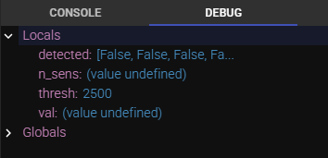

- Objective 2: Students will use the console panel again, but this time they need to be in “Console”. They will type the code after the prompts. If you see this:
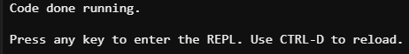
Press any key. Then you should see the prompt. Type the commands. It should look similar to this: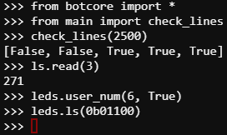
Students can try other arguments for check_lines, and other commands as well.

- The quiz brings up a problem with the code, that the values are inverted. The last question suggests a solution. Have students try the solution by changing the if statement in the function. Run the code. Then change the code back for Objective 3.
- Students answer a question from the instructions and add a while loop to the code.

